Endless SQL possibilities

You have learned that a SQL query uses **SELECT**, **FROM**, and **WHERE** to specify the data to be returned from the query. This reading provides more detailed information about formatting queries, using WHERE conditions, selecting all columns in a table, adding comments, and using aliases. All of these make it easier for you to understand (and write) queries to put SQL in action. The last section of this reading provides an example of what a data analyst would do to pull employee data for a project.

**Capitalization, indentation, and semicolons**

You can write your SQL queries in all lowercase and don’t have to worry about extra spaces between words. However, using capitalization and indentation can help you read the information more easily. Keep your queries neat, and they will be easier to review or troubleshoot if you need to check them later on.

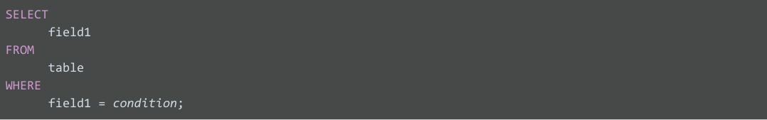

Notice that the SQL statement shown above has a semicolon at the end. The semicolon is a statement terminator and is part of the American National Standards Institute (ANSI) SQL-92 standard, which is a recommended common syntax for adoption by all SQL databases. However, not all SQL databases have adopted or enforce the semicolon, so it’s possible you may come across some SQL statements that aren’t terminated with a semicolon. If a statement works without a semicolon, it’s fine.

**WHERE conditions**

In the query shown above, the **SELECT** clause identifies the column you want to pull data from by name, **field1**, and the **FROM** clause identifies the table where the column is located by name, **table**. Finally, the **WHERE** clause narrows your query so that the database returns only the data with an exact value match or the data that matches a certain condition that you want to satisfy.

For example, if you are looking for a specific customer with the last name Chavez, the WHERE clause would be:

**WHERE field1 = 'Chavez'**

However, if you are looking for all customers with a last name that begins with the letters “Ch," the WHERE clause would be:

**WHERE field1 LIKE 'Ch%'**

You can conclude that the LIKE clause is very powerful because it allows you to tell the database to look for a certain pattern! The percent sign (%) is used as a wildcard to match one or more characters. In the example above, both **Chavez** and **Chen** would be returned. Note that in some databases an asterisk (*) is used as the wildcard instead of a percent sign (%).

**SELECT all columns**

Can you use  **SELECT \*** ?

In the example, if you replace **SELECT field1** with **SELECT \*** , you would be selecting all of the columns in the table instead of the field1 column only. From a syntax point of view, it is a correct SQL statement, but you should use the asterisk (*) sparingly and with caution. Depending on how many columns a table has, you could be selecting a tremendous amount of data. Selecting too much data can cause a query to run slowly.

**Comments**

Some tables aren’t designed with descriptive enough naming conventions. In the example, **field1** was the column for a customer’s last name, but you wouldn’t know it by the name. A better name would have been something such as **last_name**. In these cases, you can place comments alongside your SQL to help you remember what the name represents. Comments are text placed between certain characters, **/\*** and **\*/**, or after two dashes (**--**) as shown below.



Comments can also be added outside of a statement as well as within a statement. You can use this flexibility to provide an overall description of what you are going to do, step-by-step notes about how you achieve it, and why you set different parameters/conditions.

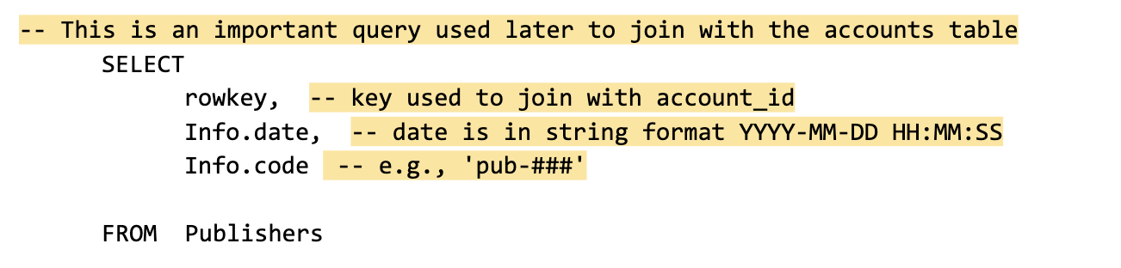

The more comfortable you get with SQL, the easier it will be to read and understand queries at a glance. Still, it never hurts to have comments in a query to remind yourself of what you’re trying to do. This also makes it easier for others to understand your query if your query is shared. As your queries become more and more complex, this practice will save you a lot of time and energy to understand complex queries you wrote months or years ago.

**Example of a query with comments**

Here is an example of how comments could be written in BigQuery:

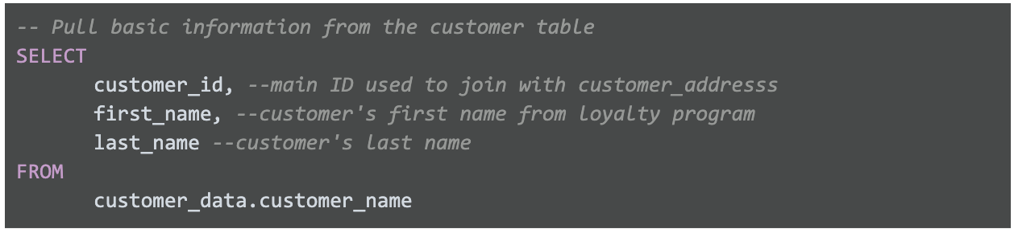

In the above example, a comment has been added before the SQL statement to explain what the query does. Additionally, a comment has been added next to each of the column names to describe the column and its use. Two dashes (--) are generally supported. So it is best to use -- and be consistent with it. You can use # in place of -- in the above query, but # is not recognized in all SQL versions; for example, MySQL doesn’t recognize #.  You can also place comments between /* and */ if the database you are using supports it.

As you develop your skills professionally, depending on the SQL database you use, you can pick the appropriate comment delimiting symbols you prefer and stick with those as a consistent style. As your queries become more and more complex, the practice of adding helpful comments will save you a lot of time and energy to understand queries that you may have written months or years prior.

**Aliases**

You can also make it easier on yourself by assigning a new name or **alias** to the column or table names to make them easier to work with (and avoid the need for comments). This is done with a SQL AS clause. In the example below, the alias **last_name** has been assigned to **field1** and the alias **customers** assigned to **table.** These aliases are good for the duration of the query only. An alias doesn’t change the actual name of a column or table in the database.

**Example of a query with aliases**

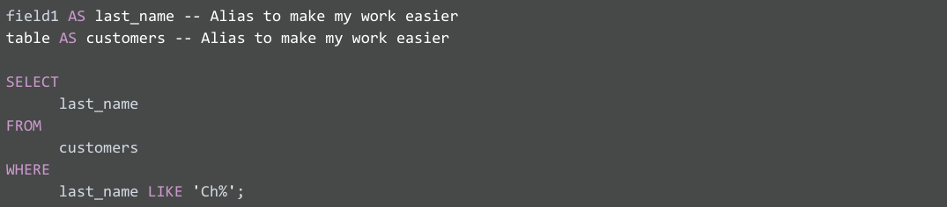

**Putting SQL to work as a data analyst**

Imagine you are a data analyst for a small business and your manager asks you for some employee data. You decide to write a query with SQL to get what you need from the database.

You want to pull all the columns: **empID**, **firstName**, **lastName**, **jobCode**, and **salary**. Because you know the database isn’t that big, instead of entering each column name in the **SELECT** clause, you use **SELECT \***.  This will select all the columns from the Employee table in the **FROM** clause.



Now, you can get more specific about the data you want from the Employee table. If you want all the data about employees working in the **SFI** job code, you can use a **WHERE** clause to filter out the data based on this additional requirement.

Here, you use:

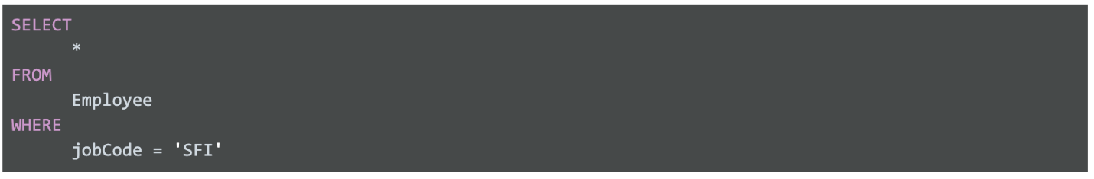

A portion of the resulting data returned from the SQL query might look like this:

| **empID** | **firstName** | **lastName** | **jobCode** | **salary** |
| --- | --- | --- | --- | --- |
| 0002 | Homer | Simpson | SFI | 15000 |
| 0003 | Marge | Simpson | SFI | 30000 |
| 0034 | Bart | Simpson | SFI | 25000 |
| 0067 | Lisa | Simpson | SFI | 38000 |
| 0088 | Ned | Flanders | SFI | 42000 |
| 0076 | Barney | Gumble | SFI | 32000 |

Suppose you notice a large salary range for the **SFI** job code. You might like to flag all employees in all departments with lower salaries for your manager. Because interns are also included in the table and they have salaries less than $30,000, you want to make sure your results give you only the full time employees with salaries that are $30,000 or less. In other words, you want to exclude interns with the **INT** job code who also earn less than $30,000. The **AND** clause enables you to test for both conditions.

You create a SQL query similar to below, where <> means "does not equal":



The resulting data from the SQL query might look like the following (interns with the job code **INT** aren't returned):

| **empID** | **firstName** | **lastName** | **jobCode** | **salary** |
| --- | --- | --- | --- | --- |
| 0002 | Homer | Simpson | SFI | 15000 |
| 0003 | Marge | Simpson | SFI | 30000 |
| 0034 | Bart | Simpson | SFI | 25000 |
| 0108 | Edna | Krabappel | TUL | 18000 |
| 0099 | Moe | Szyslak | ANA | 28000 |

With quick access to this kind of data using SQL, you can provide your manager with tons of different insights about employee data, including whether employee salaries across the business are equitable. Fortunately, the query shows only an additional two employees might need a salary adjustment and you share the results with your manager.

Pulling the data, analyzing it, and implementing a solution might ultimately help improve employee satisfaction and loyalty. That makes SQL a pretty powerful tool.

**Resources to learn more**

Nonsubscribers may access these resources for free, but if a site limits the number of free articles per month and you already reached your limit, bookmark the resource and come back to it later.

* [W3Schools SQL Tutorial](https://www.w3schools.com/sql/default.asp): If you would like to explore a detailed tutorial of SQL, this is the perfect place to start. This tutorial includes interactive examples you can edit, test, and recreate. Use it as a reference or complete the whole tutorial to practice using SQL. Click the green **Start learning SQL now** button or the **Next** buttonto begin the tutorial.
* [SQL Cheat Sheet](https://towardsdatascience.com/sql-cheat-sheet-776f8e3189fa): For more advanced learners, go through this article for standard SQL syntax used in PostgreSQL. By the time you are finished, you will know a lot more about SQL and will be prepared to use it for business analysis and other tasks.